**HOTEL RESERVATION SYSTEM**

**TOPIC:** Admin Part

**Objective:**

This mini project is one of the modules for **Hotel Reservation Project** using ABAP on SAP. This module is for **ADMIN** to access the **Booking Details** made by customer and do some functionality.

**Assumptions:**

* Only one ADMIN is present
* Only ADMIN has the rights to perform the following functions
  + Release Rooms
  + Generate Total Revenue
  + Print Revenue Report
* Customer booking was done in separate module independently
* Hotel DML operations is done in separate module independently
* All booking are done by customer and booking data is readily available in database

**Functionalities:**

* ADMIN can see a particular Hotel Details by clicking on “**Display Hotel Details**”
* ADMIN can Release Rooms by clicking on “**Release Rooms**”
* ADMIN can see Total Revenue generated based on city by clicking on “**Total Revenue**”
* ADMIN can generate an Adobe Report based on particular date range by clicking on “**Print Report**”

**Flow Logic:**

***ADMIN MAIN PAGE***

***LOGIN PAGE***

**Login Page:**

This is ADMIN Login page. In order to Sign-In admin must enter proper username and password. This username and password is validated with ZHR_ADMIN table which contains the ADMIN details. If ADMIN enters wrong username or password, an error message is displayed.

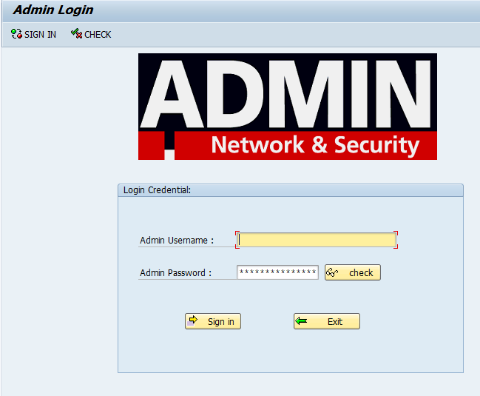 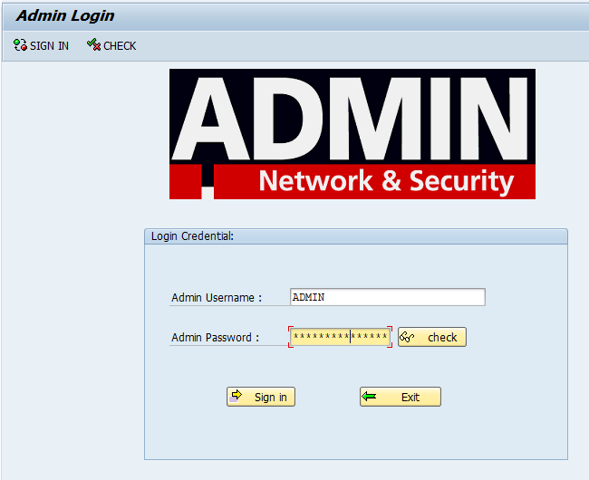

To check what password admin has entered, admin has to press the check button to see the password. And click one more time to un-see the password.

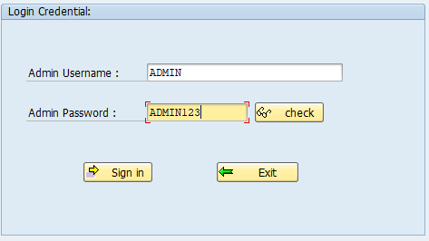

**Main page:**

In main page ADMIN has access to see the Booking Details in read-only mode.

The data is displayed in Table Control based on the city selected by the ADMIN in the main screen. The data is displayed by clicking the “**Display Booking**” button.

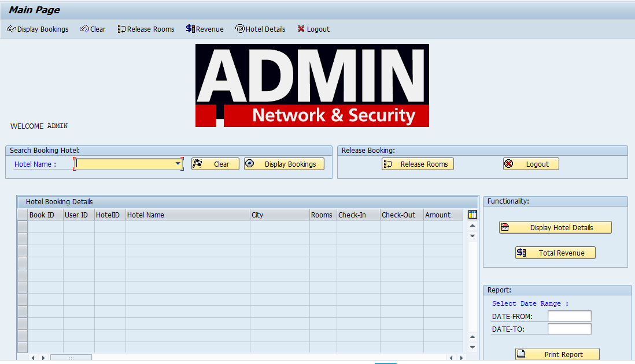

The below figure shows the booking details for hotels in Bengaluru.

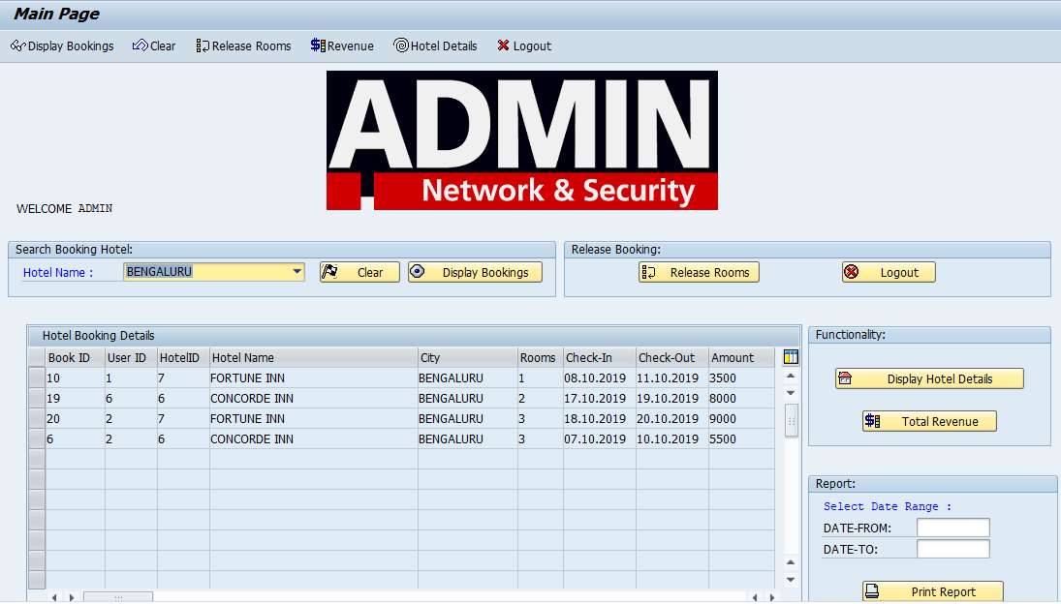

To release rooms, the admin has to press the “**release rooms**” button. A pop up message comes up to confirm admin selection. If admin clicks yes, rooms are released otherwise the action is terminated.

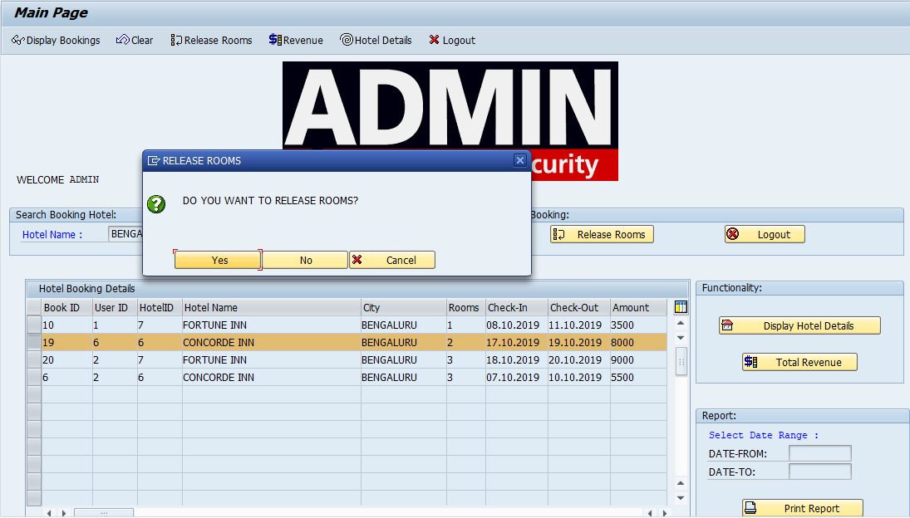

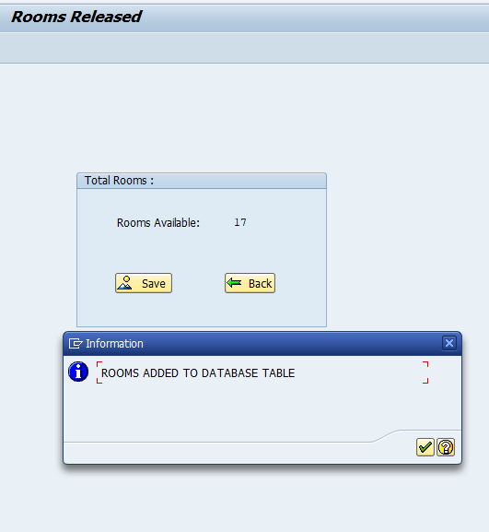

To generate total revenue based on city selected, admin has to click on “**Total Revenue**” button. An ALV is generated which displays the total revenue.

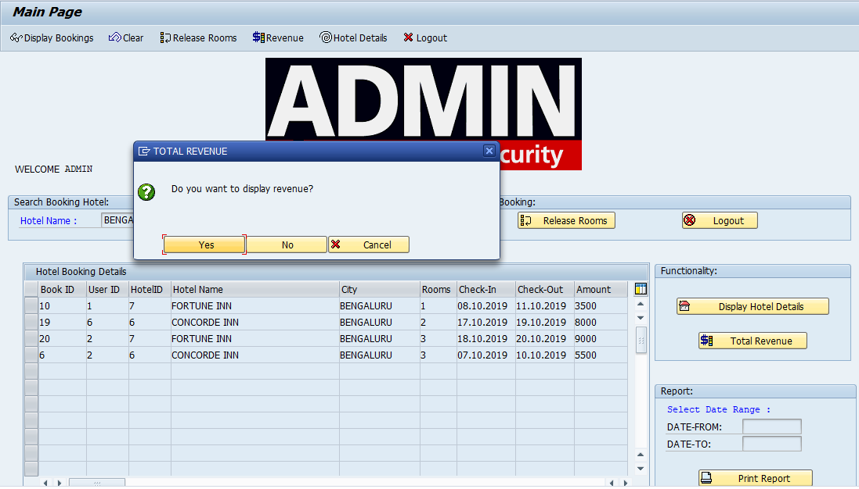

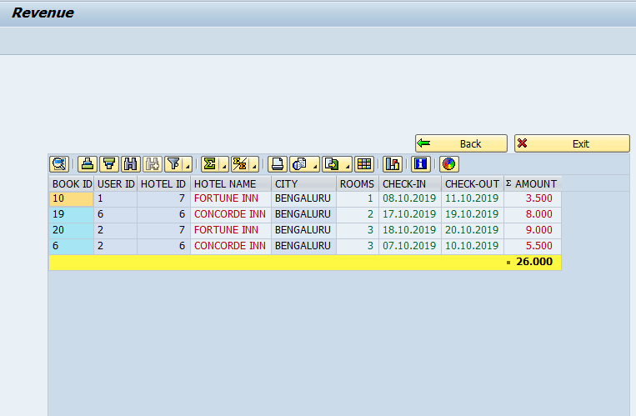

To generate a report based on particular date range selected by admin. The admin has to click “**Print Report**” button.

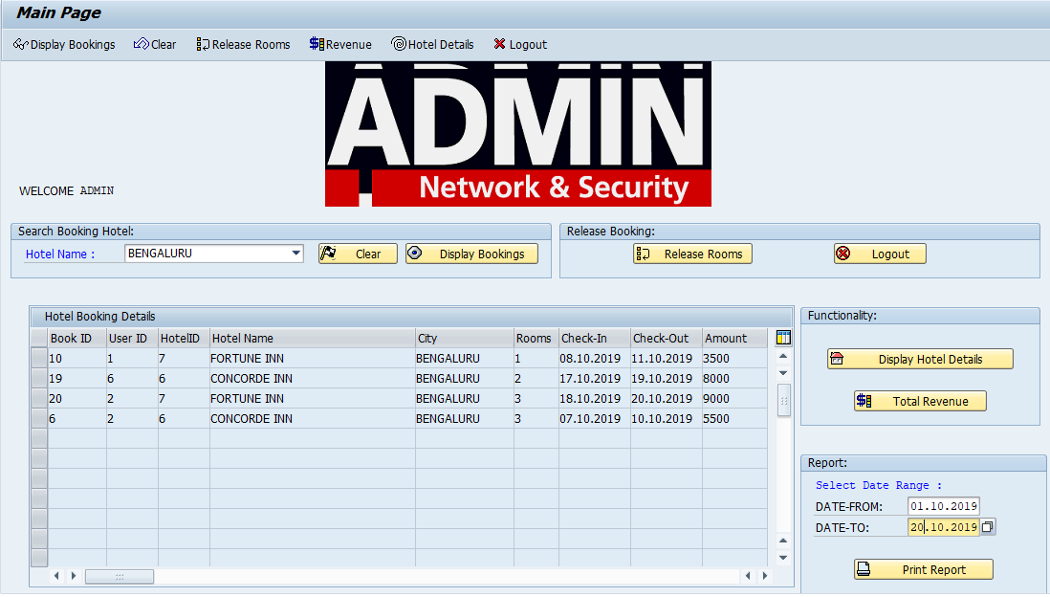

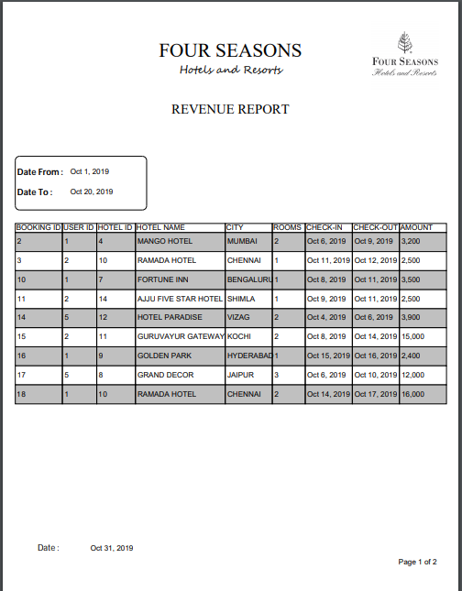

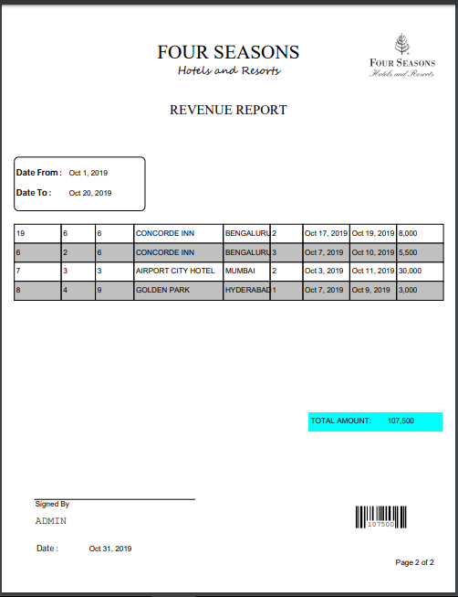

**Tables:**

1. **ZHOTEL_MASTER**

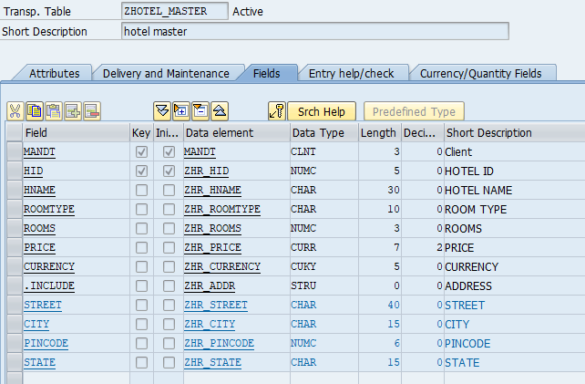

1. **ZHOTEL_BOOKING**

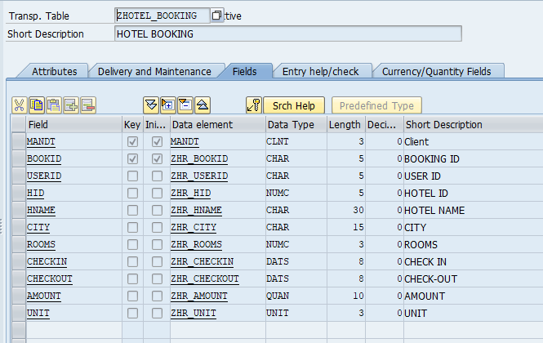

1. **ZHR_ADMIN**

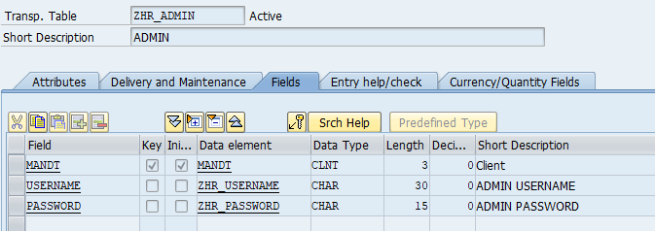

1. **ZHR_CITY1**

